**Shell**

It is an interface b/w user and karnal.

A system can have many shells running simultaneously.

Eg- sh, csh, ksh, bash (bourne again shell), powershell etc.

Bash can also read and execute commands from a file, called a shell script.

**Shell Script**

Shell script is a combination of command to ease your task.

Shell script is use to create custom command to ease your task.

It performs basic operations like :- File Manipulation & Program Execution.

**Advantage and Disadvantage**

The commands and syntax of the shell script are the same as that entered at the command line.

Shell scripting can be used by users that are not experts to modify and tailor the behaviour of their programs according to their requirements.

different platforms in Shell scripting may also have compatibility problems.

In term of rerun program again and again shell script is dangerous compare to ansible.

**3 Ways to Execute a Shell Script**

1. sh FileName.sh
2. ./FileName.sh
3. Copy or Move Script file in /usr/sbin location and then run your script only with your Script name Ex- FileName
4. And also, the file should have Execute Permissions.

**Variables**

* env command use to show all variables
* Local environment variables
* User environment variables
* System wide environment variables
* .bashrc file (terminal)
* .bashrc_profile (remote)
* Environment
* Bashrc
* Profile

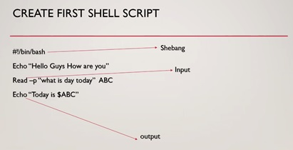

**An example of a script**

#/bin/bash

Read -p “Enter your name:- “ NAME

echo “Good Evening $NAME”

**Script for making multiple files**

#!/bin/bash

For I in {1..100}

Do

touh file$i

done

**Script for making multiple users**

#!/bin/bash

For I in {1..100}

Do

useradd user$i

done

**Script for making multiple users from a file (here Global file have multiple users name)**

#!/bin/bash

for i in `cat /root/global`

do

useradd $i

done